**Debit Card**

A debit card is a payment card that deducts money directly from your checking account. Also called “check cards” or "bank cards," debit cards can be used to buy goods or services or to get cash from an ATM. Debit card can help you reduce the need to carry cash, although using these cards can sometimes entail fees.

You can use debit cards at ATMs to withdraw cash.

Debit card purchases may require a personal identification number (PIN), but some purchases can be made without one.

You may be charged an ATM transaction fee if you use your debit card to withdraw cash from an ATM that's not affiliated with your bank.

Some debit cards offer rewards, similar to credit card rewards, such as 1% back on purchases.

Debit cards usually have daily purchase limits, meaning you can't spend more than a certain amount in one 24-hour period.

**Pros and Cons Debit Cards**

Pros

* Safer than cash
* Doesn't incur debt
* Easier qualifications than credit cards

Cons

* Limits expenditures to cash in bank and/or a daily amount
* Could incur fees
* Fewer perks than credit cards
* Fewer protections than credit cards

**Legal Age requirement to have a Debit Card?**

The age requirements for financial products like debit cards depends on the bank. Legally, U.S. financial institutions cannot provide financial products to minors, but minors still may be able to get a debit card with the inclusion of a parent or legal guardian on the account. To have a debit card in their own name, minors often have to be at least 13 years old. Still, some banks offer cards to children under 13 (in the adult's name).

**Number of Payment Cards Worldwide, By Type**

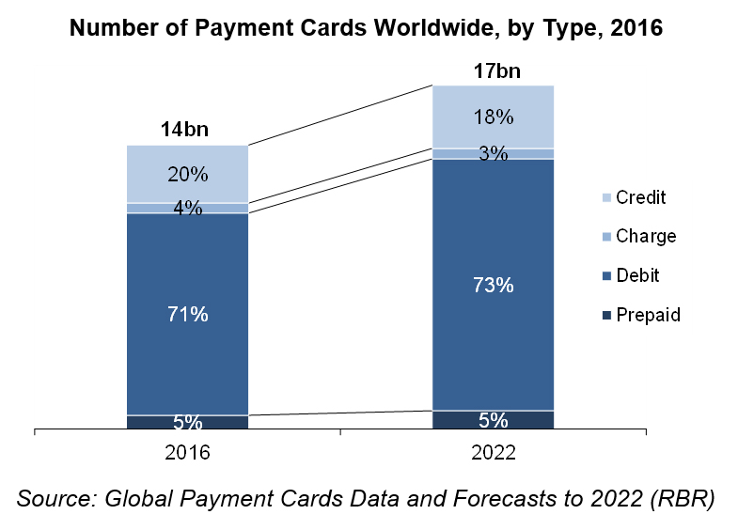

* 93% of American adults had a debit card in 2021, according to the Federal Reserve.
* 82% of American adults had a credit card in 2022, according to the Federal Reserve.
* In 2022, 60% of all cards in the United States were debit cards or prepaid debit cards, according to the Nilson Report.
* Wells Fargo had the largest debit card market share of any issuer in 2022, when measured by purchase volume: $464 billion.

**Prepaid debit cards**

Prepaid debit cards are a type of payment card that allows users to access funds that have been preloaded onto the card.

A prepaid debit card is much like a gift card: It allows you to spend whatever amount of money is stored on the card. You can reload the card online or at an ATM, a participating store, or another physical location when the balance is used up. Prepaid debit cards are issued by banks and they're branded by the major credit card companies, including Visa, MasterCard, Discover, and American Express.

* A prepaid debit card can be a useful alternative to cash.
* Prepaid debit cards are an option for people who don't have a credit card or access to a regular debit card that's connected to a bank account.
* There are many fees associated with prepaid debit cards

Some employers pay their workers with prepaid debit cards, which are referred to as payroll cards. This can be useful if the person doesn't have a bank account or direct deposit. Many government benefits, including Social Security, are also available via prepaid debit cards. If you have a company that prepares your taxes, they might offer a prepaid debit card for your refund.

Employees have a legal right to decline being paid through a payroll card because the fees will reduce their take-home pay.

The use case for prepaid debit cards such as payroll cards, healthcare spending account tools, corporate expense trackers and government payments disbursement aids continues to strengthen with growth in each of those categories. These prepaid debit cards will represent $373 billion in consumer spending in 2023.

Prepaid debit cards come with both advantages and disadvantages. The interest and fees you'd pay on a regular credit card might be less than those charged by a prepaid card issuer, but you may not qualify for a credit card.

Total Prepaid Industry GDV (In US$ Billions)

**US Prepaid Card Transaction Volume**

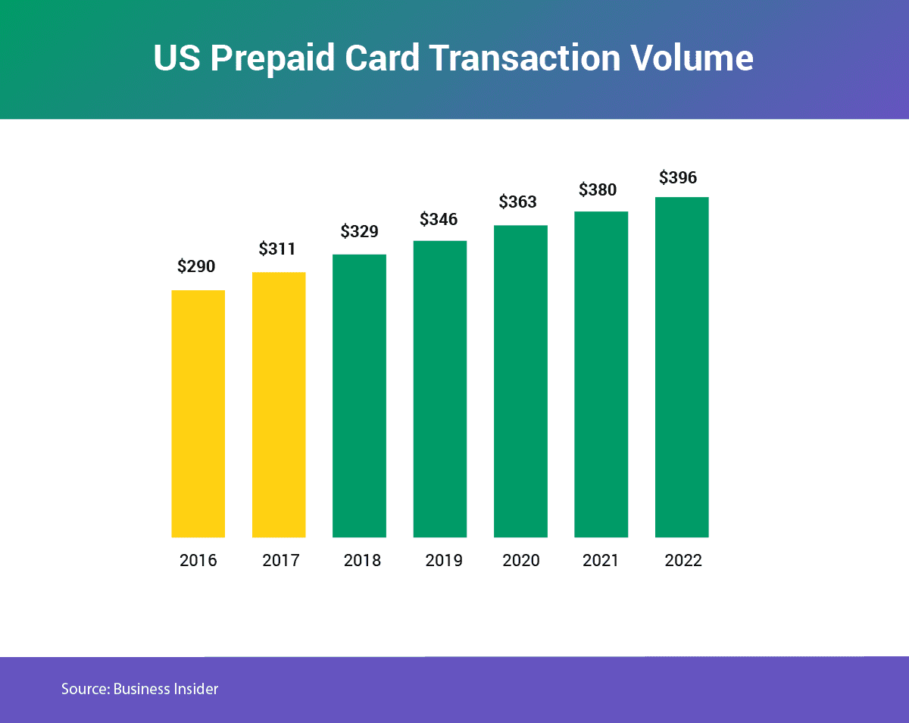

Prepaid debit card payments had the greatest growth rate by number (9.6 percent per year), reaching 18.1 billion payments in 2021.

North America Region Prepaid Card Market Share in 2022 - 38.17%